App Behaviour Analysis

Project Overview :

In today's market, many companies have a mobile presence. Often, these companies provide free products/services in their mobile apps in an attempt to transition their customers to a paid membership. Some examples of paid products, which originate from free ones, include YouTube Red, Pandora Premium, Audible Subscription and You Need a Budget. Since marketing efforts are never free, these companies need to know exactly who to target with their offers and promotions.
- Market: The target audience is customers who use a company's free product. For this project, this refers to users who installed (and used) the company's free mobile app.
- Product: The paid memberships often provide enhanced versions of the free products already given for free, alongside new features. For example, YouTube Red allows you to leave the app while still listening to a video.
- Goal: The objective of this model is to predict which users will not subscribe to the paid membership, so that greater marketing efforts can go into trying to "convert" them to paid users.

Business Challenge :

The data comes from a fintech company that wants to provide its customers with a paid mobile app subscription that will allow them to track all their finances in one place. To attract customers, the company releases a free version of their app with some of the main features unlocked.
we will identify which users will most likely NOT enroll in a paid product, so that additional offers can be given to them. Due to the costs of these offers, the company does not want to offer them to everybody, especially customers who were going to enroll anyways.

Data Overview:

We have access to the each customer's app behaviour data. This data allows us to see the date and time of app installation, as well as the features the user engaged with in the app. App behaviour is characterised as the list of app screens the user looked at and whether the user played the financial mini-games available.
The app usage data is only from the user's first day in the app. This limitation exists because users can enjoy a 24-hour free trial of the premium features and the company wants to target them with new offers shortly after the trial is over.
The data fields we'll be working with are as follows:
- first_open: The date-time when the user first opened the app
- dayofweek: the integer day of the week when the user first opened the app. Starts at 0, which is Sunday and runs to 6 which is Saturday.
- hour: Hour of the day when user first opened app. in 24 hours format as 18:00:00. Correlates with dayofweek.
- age: Age of the user.
- screen_list: Comma-seperated list of screens that the users accessed in their first 24 hours.
- numscreens: The number of screens accessed in their first 24 hours.
- liked: Each screen has an feature to 'like' that particualr screen. If any screens are liked, this value will be 1, otherwise 0.
- minigame: 1 if the user played the mini-game, 0 otherwise.
- used_premium_feature: 1 if the user accessed any of the premium features in the first 24 hours, 0 otherwise.
- enrolled: 1 if the user enrolled, 0 otherwise. This is the field that will be predicted later.
- enrolled_date: If the user enrolled at any time, this value is popopulated with the date of enrollment.

Python Libraries :

We used numpy , pandas , matplotlib , seaborn , deteutil libraries here.

Histograms :

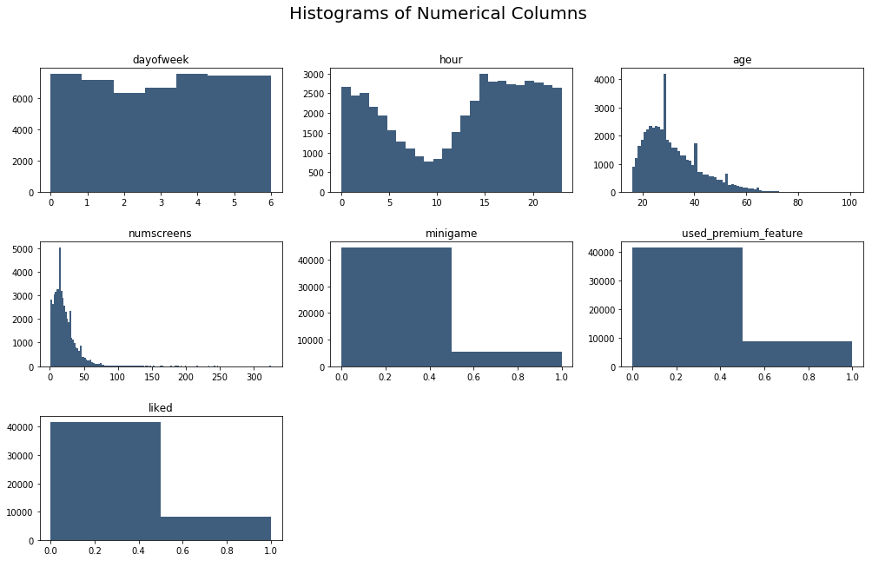

Findings:
- Not a huge preference singing up on a specific day.
- Hour is in UTC time so the major dip we see represents sleeping time for most people.
- Most signups tends to be from younger people (right-skewed age) with a few big spikes around 30, 40 and 50.
- A few outliers access a large number of screens but generally most people access less than 25 screens.
- Most people do not play the mini game or use premium features.
- Most people have not liked any of the app features.

Investigating Correlations with Response Variable :

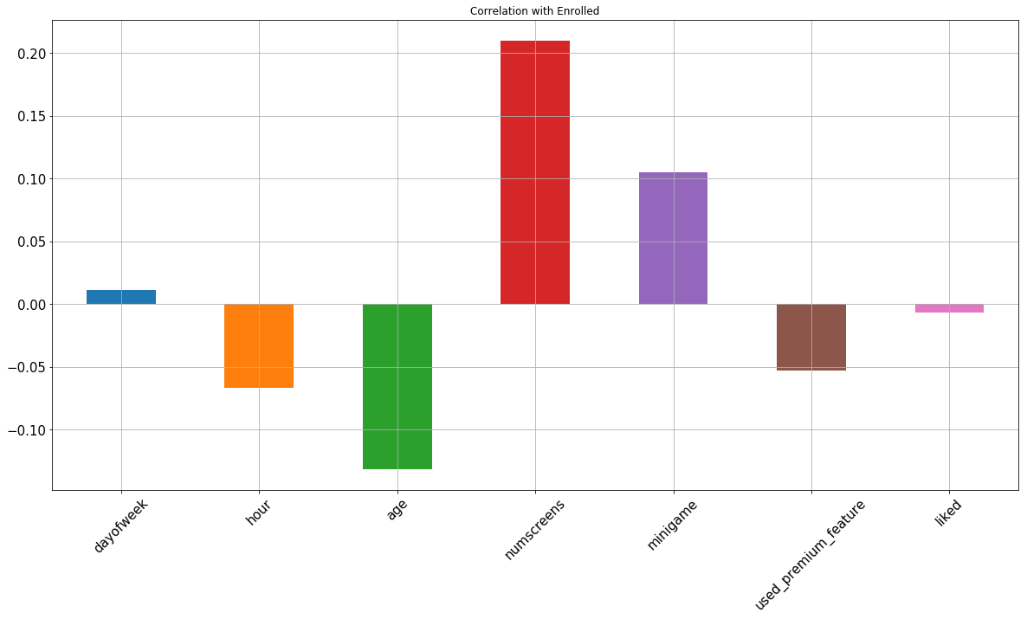
Findings:
- Older people tend to sign up less.
- The more screens someone used, the more likely they are to sign up.
- People playing the mini-game tend to sign up, however it's a weak positive correlation.
- People who use the app at earlier hours tend to sign up less, however it's a very weak negative correlation.
- The more people use premium features, the less likely they are to enrol, however it's a very weak negative correlation.
- Whether users like a feature or not seems to have no correlation on whether they sign up or not.
Let's plot a correlation matrix to see if there are dependencies between the variables.
Correlation Matrix :
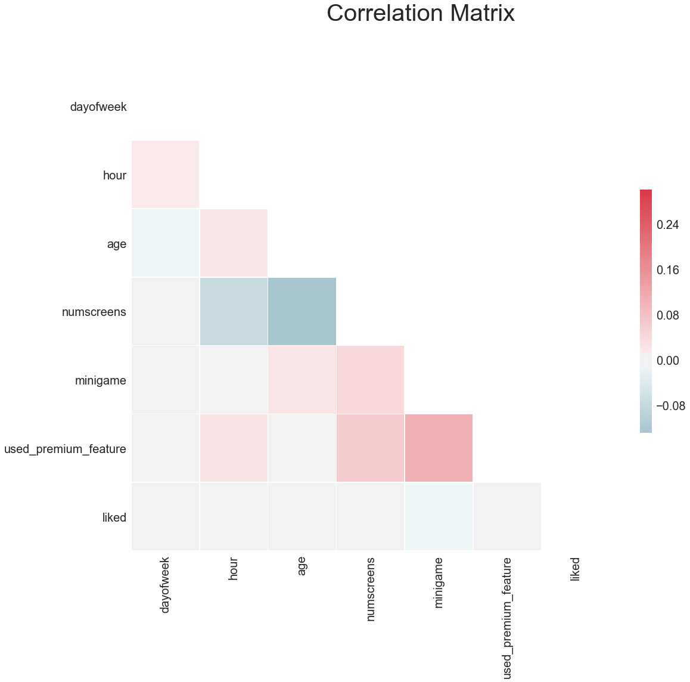

No strong correlations between variables. Older people may access less screen and the more screens a person accesses the more likely they are to use a premium feature. If they play a mini-game they are more likely to use a premium feature as well.

Feature Engineering - Time between signup and enrollment :

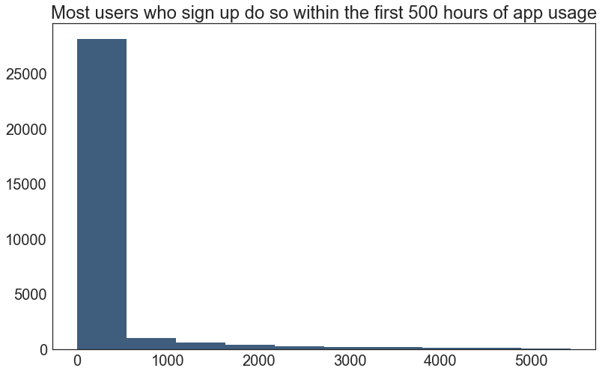
It seems that most users who do sign up, do so within the first 500 hours. However we could check within this first 500 hours for a more specific breakdown.

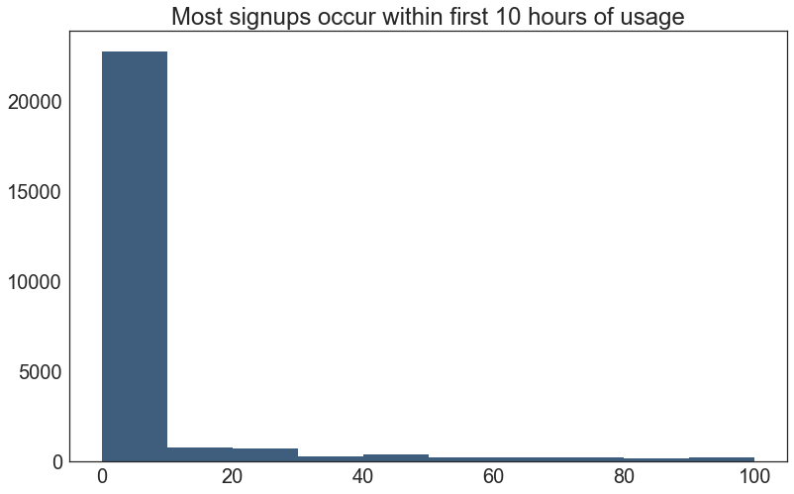
It looks like most signups actually happen within the first 10 hours. Let's break it down further.
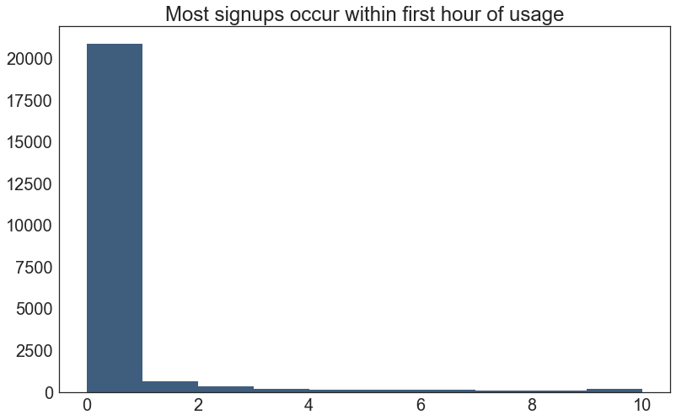
It looks like the first hour of usuage is where most users decided whether to sign up or not.
For modelling purposes, let's limit our data to those they have enrolled within 2 days of usage since after that we are creating a very skewed set in the repsonse variable which isn't ideal for modelling.

Feature Engineering - Screens Accessed :

We need to convert the comma-seperated list of screens accessed into a format suitable for modelling.
top_screens.csv is provided by the company and shows the top screen accessed by each user. We can use this to limit the number of columns that are generated to only those that represent the top-accessed screens. Doing this reduces the number of features generated.
We want to create a set of dummy variables for the top screens, i.e. if the user has accecssed a partciualr top screen, make it a 1, otherwise 0. Then create an 'Other" field which maintains a could of the other non-top screens they also accessed.

Model Building :

Lasso regularization will be used to strongly penalise any variable that is strongly correlated with the target variable. For example, if a payment screen always proceeds the final enrollment thank you screen, then these highly correlated screens might skew the model.
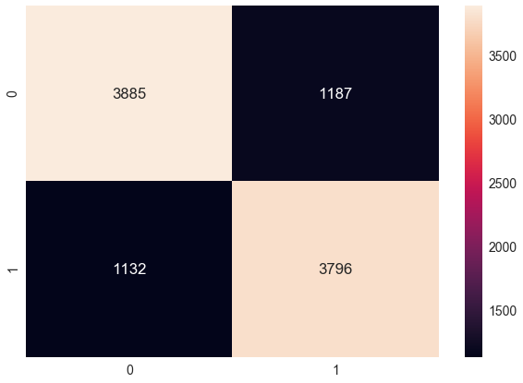
Test data accuracy : 0.7681

classification_report :

 | precision | recall | f1-score | support
0 | 0.77 | 0.77 | 0.77 | 5072
1 | 0.76 | 0.77 | 0.77 | 4928
avg / total | 0.77 | 0.77 | 0.77 | 10000

confusion_matrix :

[[3886 1186]
[1133 3795]]

Logistic Accuracy : 0.767 (+/- 0.005 std. dev)

Presenting Final Results :

 | User | Enrolled | Predicted
0 | 239786 | 1 | 1
1 | 279644 | 1 | 1
2 | 98290 | 0 | 0
3 | 170150 | 1 | 1
4 | 237568 | 1 | 1
5 | 65042 | 1 | 0
6 | 207226 | 1 | 1
7 | 363062 | 0 | 0
8 | 152296 | 1 | 1
9 | 64484 | 0 | 0
10 | 38108 | 1 | 1
... | ... | ... | ...
9990 | 347521 | 0 | 0
9991 | 335029 | 1 | 0
9992 | 37271 | 1 | 0
9993 | 240006 | 1 | 1
9994 | 279449 | 0 | 1
9995 | 143036 | 1 | 0
9996 | 91158 | 1 | 1
9997 | 248318 | 0 | 0
9998 | 142418 | 1 | 1
9999 | 279355 | 1 | 1

10000 rows × 3 columns

Conclusion :

Our efforts have given us a model that will label every new user as "highly likely" or "unlikely" to subscribe. We can further validate our results by running our predictions on daily new installs and see whether our accuracy is consistant. From there, we can narrow our marketing efforts only for those users who are "unlikely" to subscribe and thus increase our subscriber rate.
The increase in overall subscriptions can measure the benefit of this model to the company. Recall that those already likely to subscribe will do so and although we can still give them offers, we don't have to go all out. On the other hand, users who are likely to leave may convert to paid subscribers if we give them an offer they cannot refuse.
For example, these offers could come in the form of "1st free month" or 50% off yearly subscriptions. The latter shows that great offers can still be structured in a way that brings overall benefit to the company because we are locking the user in for an extended period.

